**Listeners**

A listener is a component that shows the results of the samples. The results can be shown in a tree, tables, and graphs or simply written to a log file. To view the contents of a response from any given sampler, add either of the Listeners **"View Results Tree"** or **"View Results in table"** to a test plan. To view the response time graphically, add graph results, spline results or distribution graph. The[listeners](http://jmeter.apache.org/usermanual/component_reference.html#listeners) section of the components page has full descriptions of all the listeners.

**Types of Listeners:**

* Sample Data Writer
* View Results Tree
* View Results In Table
* Summary Results

1. **Sample Data Writer:**This listener can record results to a file but not to the UI. It is meant to provide an efficient means of recording data by eliminating GUI overhead. When running in non-GUI mode, the -1 flag can be used to create a data file. The fields to save are defined by Jmeter properties. See the jmeter.properties file for details.

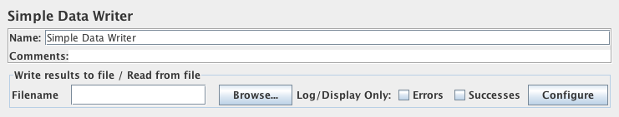

1. **View Results Tree:**The View Results Tree shows a tree of all sample responses, allowing you to view the response for any sample. In addition to showing the response, you can see the time it took to get this response, and some response codes. Note that the Request panel only shows the headers added by Jmeter. It does not show any headers (such as Host) that may be added by the HTTP protocol implementation.

**NOTE:** View Results Tree MUST NOT BE USED during load test as it consumes a lot of resources (Memory and CPU). Use it only for either functional testing or during Test Plan debugging and Validation.

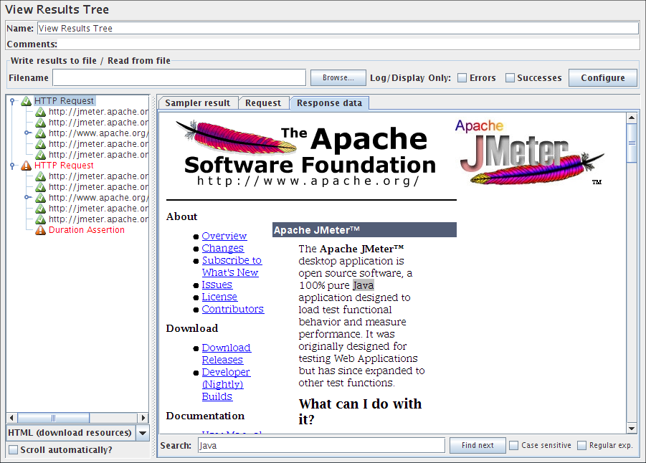

There are several ways to view the response, selectable by a drop-down box at the bottom of the left had panel.

|  |
| --- |
|  |
| |  |  |  |  |  |  |  |  |  |  |  |  |  |  |  |  |  |  |  |  |  |  |  |  | | --- | --- | --- | --- | --- | --- | --- | --- | --- | --- | --- | --- | --- | --- | --- | --- | --- | --- | --- | --- | --- | --- | --- | --- | | |  |  |  |  |  |  |  |  |  |  |  |  |  |  |  |  |  |  |  |  |  |  |  | | --- | --- | --- | --- | --- | --- | --- | --- | --- | --- | --- | --- | --- | --- | --- | --- | --- | --- | --- | --- | --- | --- | --- | | |  |  |  |  |  |  |  |  |  |  |  |  |  |  |  |  |  |  |  |  |  |  | | --- | --- | --- | --- | --- | --- | --- | --- | --- | --- | --- | --- | --- | --- | --- | --- | --- | --- | --- | --- | --- | --- | | |  |  |  |  |  |  |  |  |  |  |  |  |  |  |  |  |  |  |  |  |  | | --- | --- | --- | --- | --- | --- | --- | --- | --- | --- | --- | --- | --- | --- | --- | --- | --- | --- | --- | --- | --- | | |  |  | | --- | --- | | **Renderer** | **Description** | | **CSS/JQuery Tester** | The *CSS/JQuery Tester* only works for text responses. It shows the plain text in the upper panel. The "Test" button allows the user to apply the CSS/JQuery to the upper panel and the results will be displayed in the lower panel. The engine of CSS/JQuery expression can be JSoup or Jodd, syntax of these 2 implementation differs slightly. For example, the Selector **a[class=sectionlink]** with attribute **href** applied to the current JMeter functions page gives the following output:  Match count: 74  Match[1]=#functions  Match[2]=#what_can_do  Match[3]=#where  Match[4]=#how  Match[5]=#function_helper  Match[6]=#functions  Match[7]=#__regexFunction  Match[8]=#__regexFunction_parms  Match[9]=#__counter  ... and so on ... | | **Document** | The *Document view* will show the extract text from various type of documents like Microsoft Office (Word, Excel, PowerPoint 97-2003, 2007-2010 (openxml), Apache OpenOffice (writer, calc, impress), HTML, gzip, jar/zip files (list of content), and some meta-data on "multimedia" files like mp3, mp4, flv, etc. The complete list of support format is available on [Apache Tika format page.](http://tika.apache.org/1.2/formats.html)  **Note:** A requirement to the *Document view* is to download the [Apache Tika binary package](http://tika.apache.org/download.html) (tika-app-x.x.jar) and put this in JMETER_HOME/lib directory.  If the document is larger than 10 MB, then it won't be displayed. To change this limit, set the JMeter property **document.max_size** (unit is byte) or set to 0 to remove the limit. | | **HTML** | The *HTML view* attempts to render the response as HTML. The rendered HTML is likely to compare poorly to the view one would get in any web browser; however, it does provide a quick approximation that is helpful for initial result evaluation. Images, style-sheets, etc. aren't downloaded. | | **HTML (download resources)** | If the *HTML (download resources) view* option is selected, the renderer may download images, style-sheets, etc. referenced by the HTML code. | | **JSON** | The *JSON view* will show the response in tree style (also handles JSON embedded in JavaScript). | | **Regexp Tester** | The *Regexp Tester view* only works for text responses. It shows the plain text in the upper panel. The "Test" button allows the user to apply the Regular Expression to the upper panel and the results will be displayed in the lower panel. The engine of regular expression is the same that the Regular Expression Extractor. For example, the RE **(JMeter\w*).\*** applied to the current JMeter home page gives the following output:  Match count: 26  Match[1][0]=JMeter - Apache JMeter&lt;/title>  Match[1][1]=JMeter  Match[2][0]=JMeter" title="JMeter" border="0"/>&lt;/a>  Match[2][1]=JMeter  Match[3][0]=JMeterCommitters">Contributors&lt;/a>  Match[3][1]=JMeterCommitters  ... and so on ...  The first number in [] is the match number; the second number is the group. Group [0] is whatever matched the whole RE. Group [1] is whatever matched the 1st group, i.e. (JMeter\w*) in this case. See Figure 9b (below). | | **Text** | The default *Text view* shows all of the text contained in the response. Note that this will only work if the response content-type is considered to be text. If the content-type begins with any of the following, it is considered as binary, otherwise it is considered to be text.  image/  audio/  video/ | | **XML** | The *XML view* will show response in tree style. Any DTD nodes or Prolog nodes will not show up in tree; however, response may contain those nodes. | | **XPath Tester** | The *XPath Tester* only works for text responses. It shows the plain text in the upper panel. The "Test" button allows the user to apply the XPath query to the upper panel and the results will be displayed in the lower panel. | | | | | |

The Control Panel (above) shows an example of an HTML display.  
Figure 9 (below) shows an example of an XML display.  
Figure 9a (below) shows an example of anRegexp tester display.  
Figure 9b (below) shows an example of an Document display.

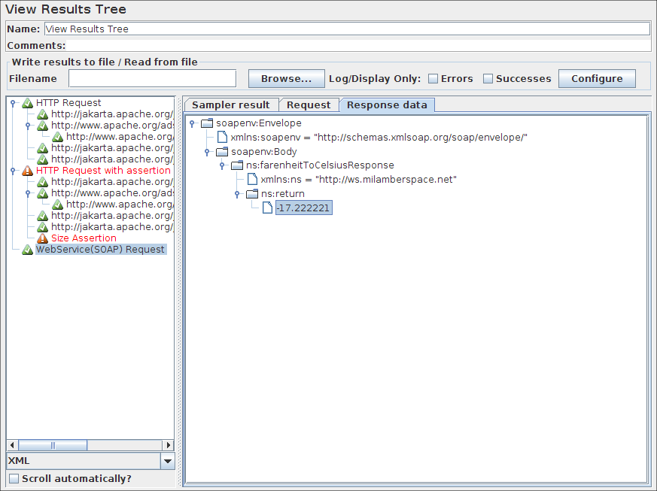

Figure 9 Sample XML display

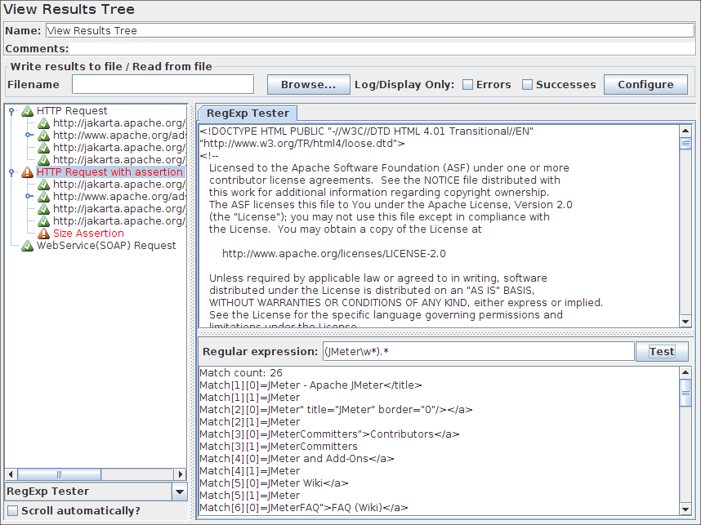

Figure 9a Sample Regexp Test display

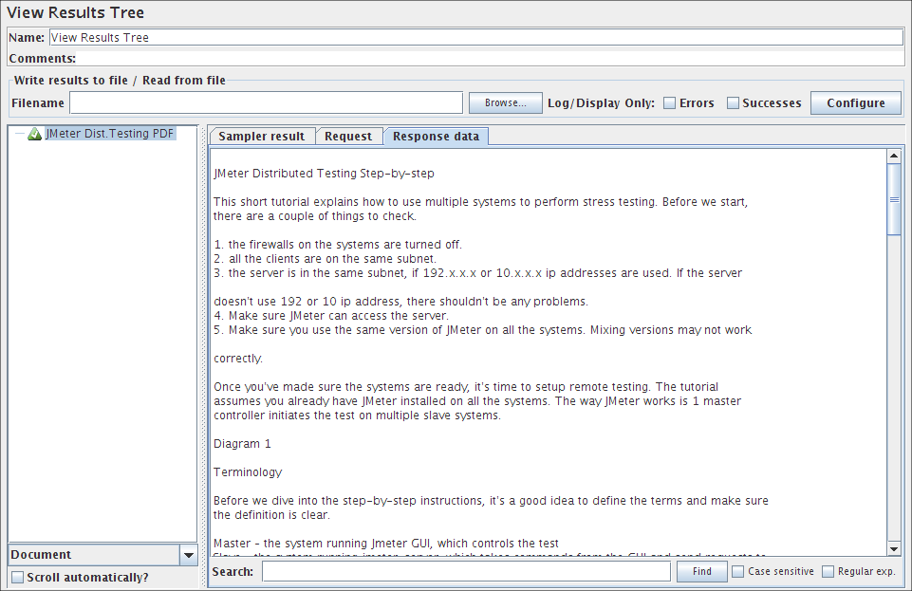

Figure 9b Sample Document (here PDF) display

1. **View Results Tree:** This visualizer creates a row for every sample result. Like the [View Results Tree](http://jmeter.apache.org/usermanual/component_reference.html#View_Results_Tree), this visualizer uses a lot of memory.

By default, it only displays the main (parent) samples; it does not display the sub-samples (child samples). Versions of JMeter after 2.5.1 have a "Child Samples?" check-box. If this is selected, then the sub-samples are displayed instead of the main samples.

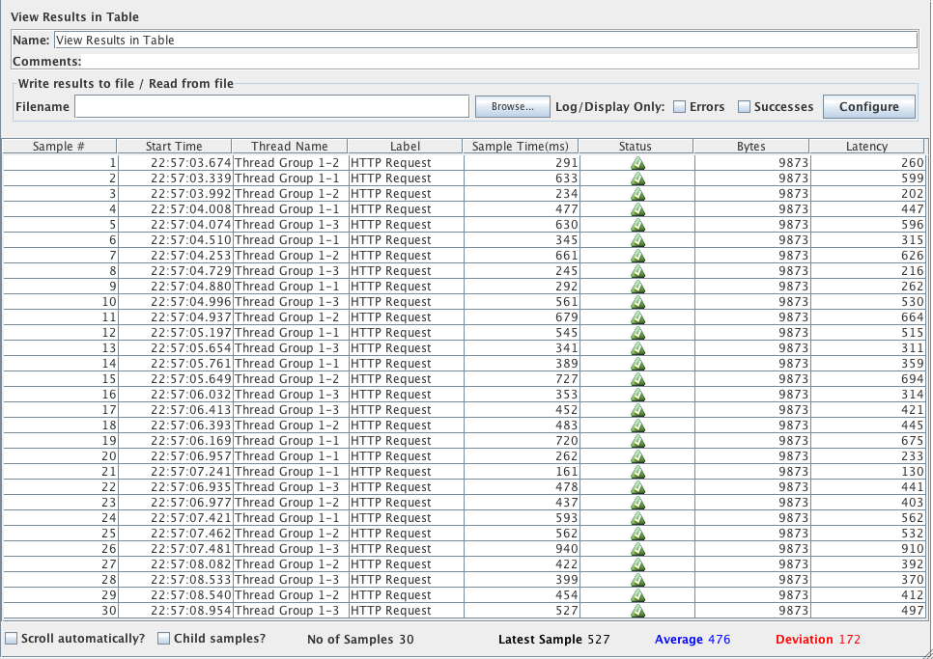

1. **Summary Report:** The summary report creates a table row for each differently named request in your test. This is similar to the [Aggregate Report](http://jmeter.apache.org/usermanual/component_reference.html#Aggregate_Report) , except that it uses less memory.

The throughput is calculated from the point of view of the sampler target (e.g. the remote server in the case of HTTP samples). JMeter takes into account the total time over which the requests have been generated. If other samplers and timers are in the same thread, these will increase the total time, and therefore reduce the throughput value. So two identical samplers with different names will have half the throughput of two samplers with the same name. It is important to choose the sampler labels correctly to get the best results from the Report.

* Label - The label of the sample. If "Include group name in label?" is selected, then the name of the thread group is added as a prefix. This allows identical labels from different thread groups to be collated separately if required.
* # Samples - The number of samples with the same label
* Average - The average elapsed time of a set of results
* Min - The lowest elapsed time for the samples with the same label
* Max - The longest elapsed time for the samples with the same label
* Std. Dev. - the [Standard Deviation](http://jmeter.apache.org/usermanual/glossary.html#StandardDeviation) of the sample elapsed time
* Error % - Percent of requests with errors
* Throughput - the [Throughput](http://jmeter.apache.org/usermanual/glossary.html#Throughput) is measured in requests per second/minute/hour. The time unit is chosen so that the displayed rate is at least 1.0. When the throughput is saved to a CSV file, it is expressed in requests/second, i.e. 30.0 requests/minute is saved as 0.5.
* Kb/sec - The throughput measured in Kilobytes per second
* Avg. Bytes - average size of the sample response in bytes. (in JMeter 2.2 it wrongly showed the value in kb)

Times are in milliseconds.

The figure below shows an example of selecting the "Include group name" checkbox.

